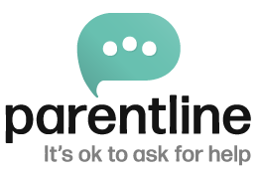
The main object for which Parentline is established is the advancement of community welfare by providing free, confidential, non-judgmental guidance and support to the parenting community, including, but not limited to parents, guardians, teachers and social workers, and to advance the education of the parenting community.

Charities Regulator Governance Code Compliance Statement.

The Parentline Board has a duty to comply with The Charities Governance Code, which sets out a mandatory standard for governance in Irish charities with implementation from 2020 onwards.

Implementation of the Code was accomplished by the Parentline Board in 2020 and prior to the prescribed deadline.

The Charities Governance Code is reviewed and updated annually by the Parentline Governance and Risk Sub-committee (GARC) and thereafter brought to the Parentline Board for approval and ratification. The most recent annual review and update was in January 2026.

There is now a suite of 36 operational and board policies and procedures in line with what is necessary to maintain a well-run charity. All the documents are available at the Parentline offices, Carmichael House, 4-7 North Brunswick Street, Dublin 7. DO7RHA8. The documents relevant to the public are available on our website www.parentline.ie.

Parentline is compliant with the Code and the Board is very happy that its policies are relevant and meaningful. Governance, of course, is an ongoing process dealt with at every Board meeting. The policies and procedures will be reviewed regularly to ensure Parentline is at the forefront of good governance practices

January 28th 2026

